Questions – Meeting for the first time

Basic Questions

1. What is your name?
2. How old are you?
3. What kind of music do you listen to?
4. How do you spend your free time?

**With family**

**With friends**

**Playing sports/gym**

**Relaxing/listening to music (Time by myself/hobbies)**

**Catching up on work**

1. What is your favourite book and why?
2. What is your strongest personal quality?

**Honest Friendly**

**Mature Good-Tempered**

**Understanding Relaxed**

**Loyal Bold**

**Trustworthy Dependable**

**Quiet Outspoken**

1. What was your most embarrassing moment?

**Something that has happened in the past or recently, that you feel comfortable sharing**

1. What are your hobbies?

**Something that you enjoy doing in your free time**

1. What do you do for a living?

**Give a brief explanation as to why you chose this career path**

1. What is your biggest fear?

**A phobia?**

**An animal?**

**The dark?**

**Ghosts?**

1. Do you have a nickname?
2. Where do you see yourself in 5 years?

**Explain any goals you hope to achieve and reach in the future**

1. How many language do you speak?

**Go into detail of what languages you can speak**

1. What do you appreciate most about your life?

**Your family – Supportive? Look after you?**

**Your friends – Supportive? Look after you?**

**Job – Doing something that you enjoy and have a passion for**

**Partner/Boyfriend/Girlfriend**

**Religion- Gives guidance**

**My health**

1. Which school/college/university did you go to?
2. Where is your favourite place to eat?

**Name your favourite restaurant**

1. What’s your least favourite food?
2. What’s your worst habit?

**A negative behaviour pattern example:**

**Procrastination**

**Fidgeting**

**Overspending**

**Gossiping**

1. Are you an early bird or a night owl?
2. Do you like to travel and where have you been?

**Name a place you would like to travel and tell them about the places you have visited**

1. Do you have any brothers and sisters?
2. What would be your ideal job, if you could do anything?
3. What is the craziest thing you have ever done?

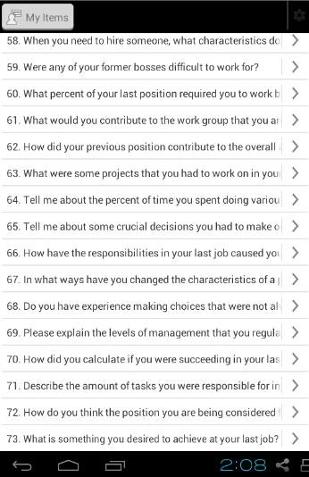

Other Apps:

**101 Interview Questions**

* Layout is poor
* Too many questions
* Too much scrolling
* No background colour/bland
* 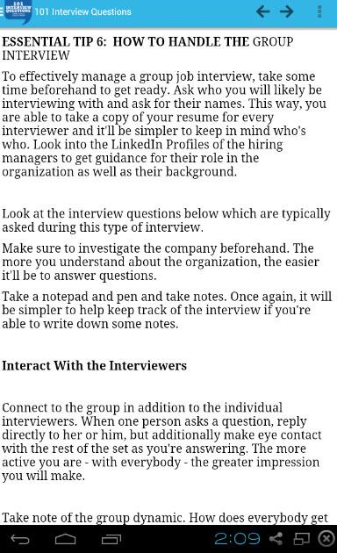101 questions but too many similar questions
* Too much information and the display of text is not attractive
* Questions have not been answered, only tips provided
* Presentation is very poor

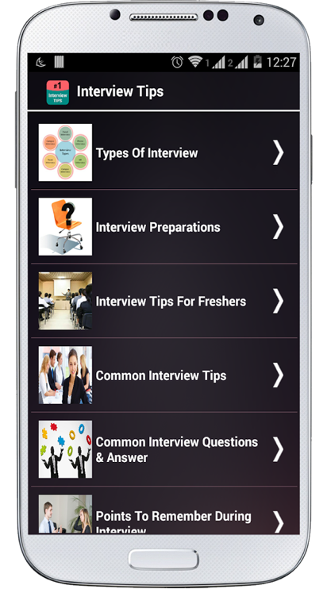**Interview Preparation Tips**

* Presentation is good and clear
* Right amount of content
* Pictures have been used accordingly to match each category
* Colourful
* Good user interface
* The right amount of information, which has been displayed clearly
* Colour through the use of pictures as well as the picture referring to the content
* Colour of text stands out on the background used